ASSIGNMENT-3

1.

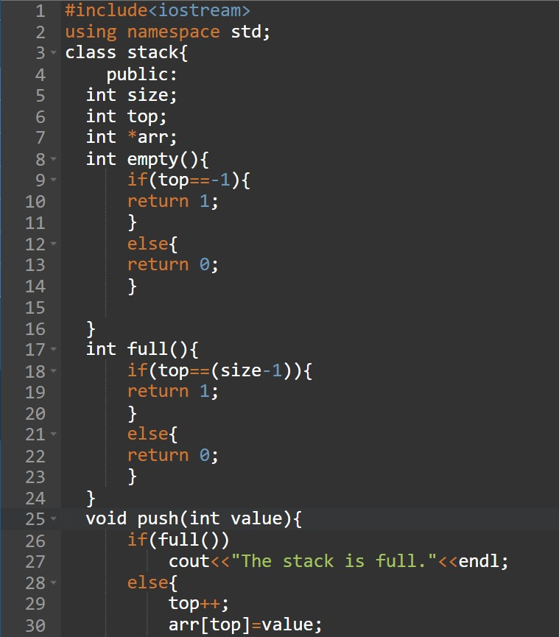

ASSIGNMENT-4

1. 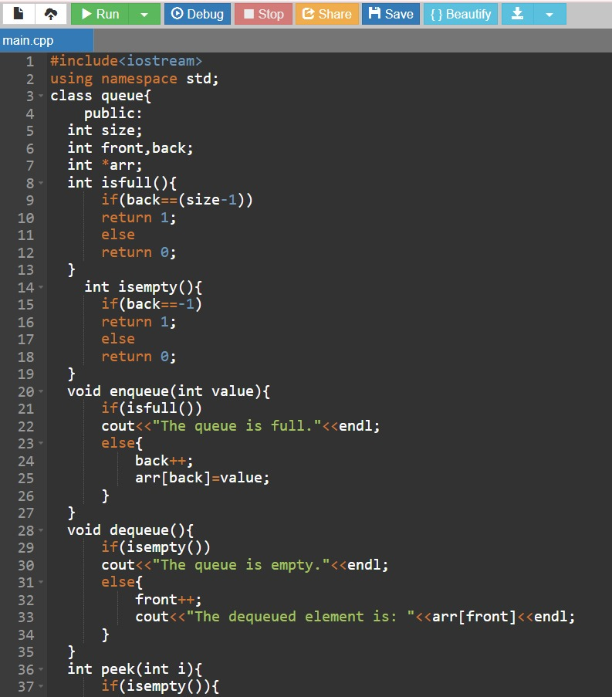

2. 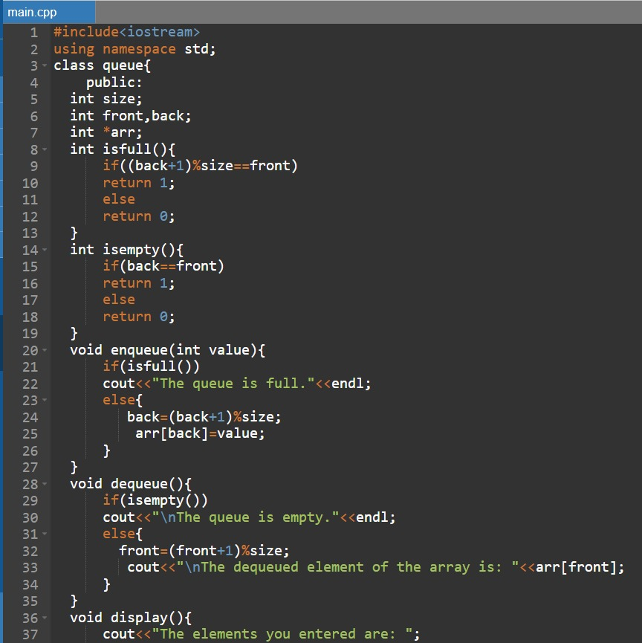

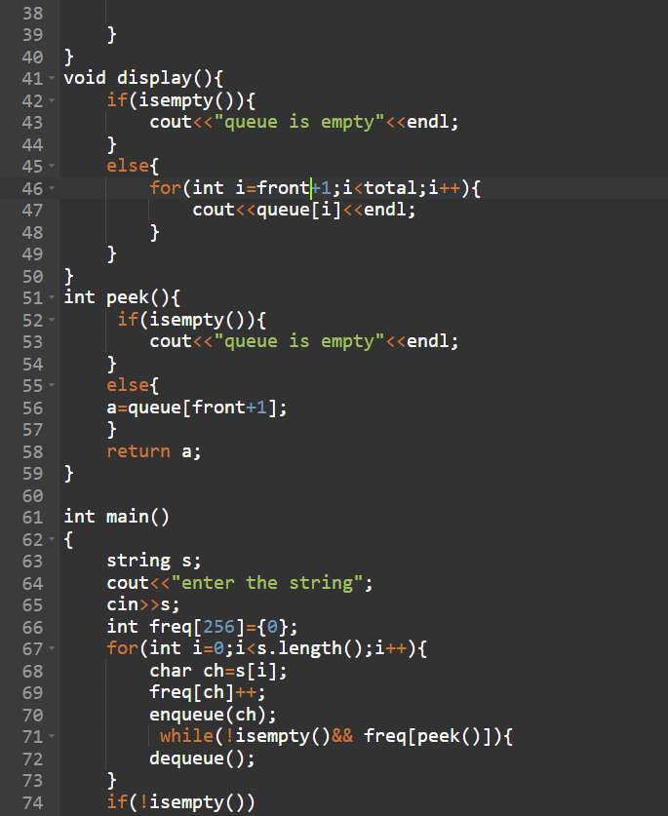

5(a)

5(b)

3.

